
IT-SIMPLERA INSTITUTE
Network Administration Internship Program
WEEK 02 ASSIGNMENT

Name | Usman Naseer
Role | Network Administrator
Supervisor | JAWAD QAYUM  (Senior Network Administrator)
Department | Network Administration
Dated | 8 July 2026

IP Addressing (FLSM & VLSM) and VLAN Configuration
This assignment repot is based upon the tasks of week 2.
In which the main focus was on Subnetting
- Fix length subnet mask
- Vriable length subnet mask
And vlans.
Question
What is Subnetting?
Subnetting is basically an address management technique to assign the ip addresses to the different interfaces of the router from the same network instead of buying the new network for every interface.
There are basically two ways subnetting can be done:
- FLSM
- VLSM
Question
What is FLSM and What is VLSM?
FLSM
FLSM or fix length subnet mask is that kind of subnetting in which the slash remains same throughout the subnetting .
VLSM
Where as in the case of vlsm the slash changes throughout the subnetting we only divide the network or subnet according to our required number of ips.

TASK 1
In our task 1 we will be performing the lab of FLSM in which we have a private network for the internal network of our company 192.168.10.0/24.
Here let we have our main router of the company connected to the internet via public ip through any xyz internet service provider. But in the inner side of our company we have 2 different deparments and we have to allocate ips to the both departments but we have only one network and we can’t assign ips to the two different interfaces of the router from the same network. Now what we can do:
We will divide the network into two subnets:
- 192.168.10.0/25
- 192.168.10.128/25
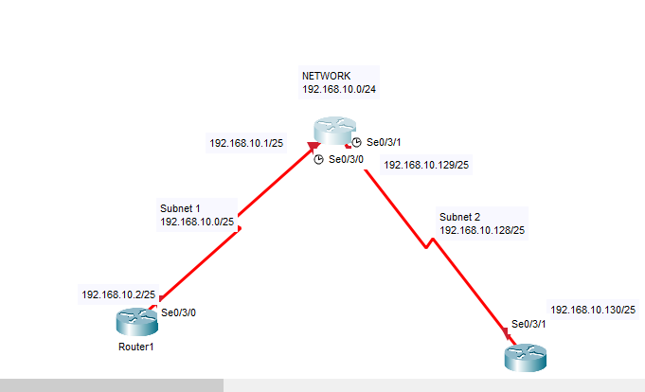
So this is our first topology we will be working upon which so we have a main router R0 and 2 routers connected to it representing our 2 different departments.
Now we will assign ips to the router interfaces:
SUBNET | SUBNET MASK | IPs
192.168.10.0/25 | 255.255.255.128 | 192.168.10.0 ->192.168.10.127
192.168.10.128/25 | 255.255.255.128 | 192.168.10.128->192.168.10.255

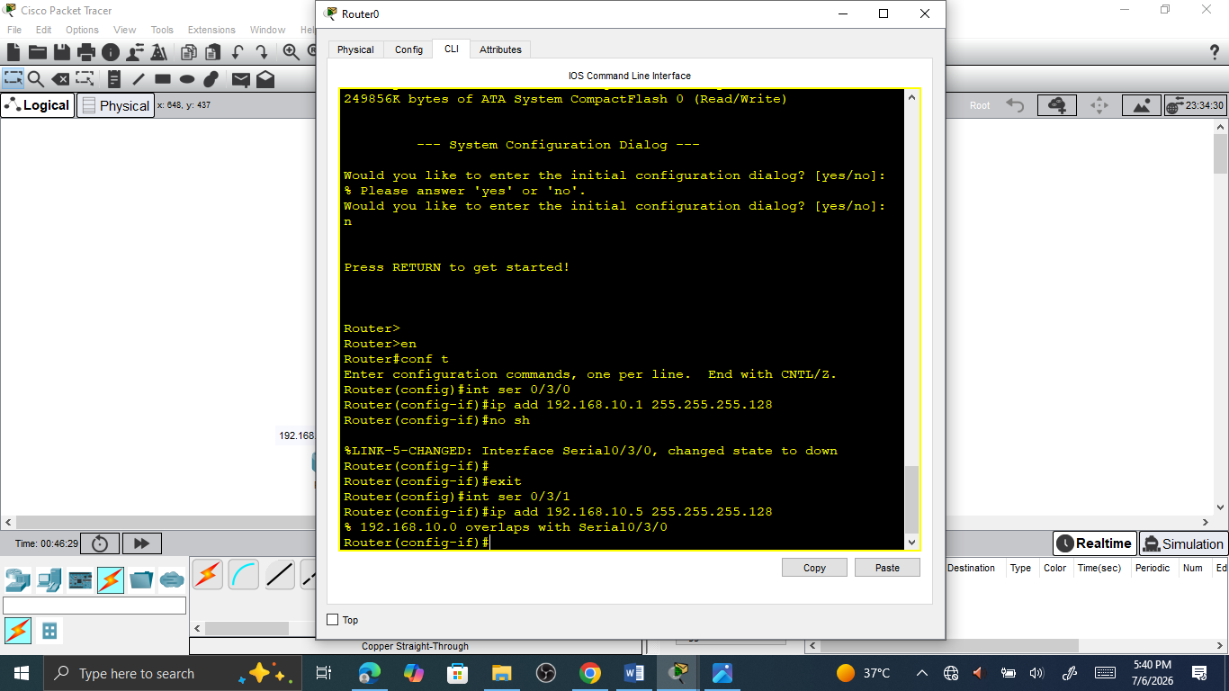
So here we tried to assign the ip to the 2 different interfaces of the router from the same network and what was the response we have ?
192.168.10.0 overlaps with Serial0/3/0
this ip overlaps with the serial 0/3/0 interface network.
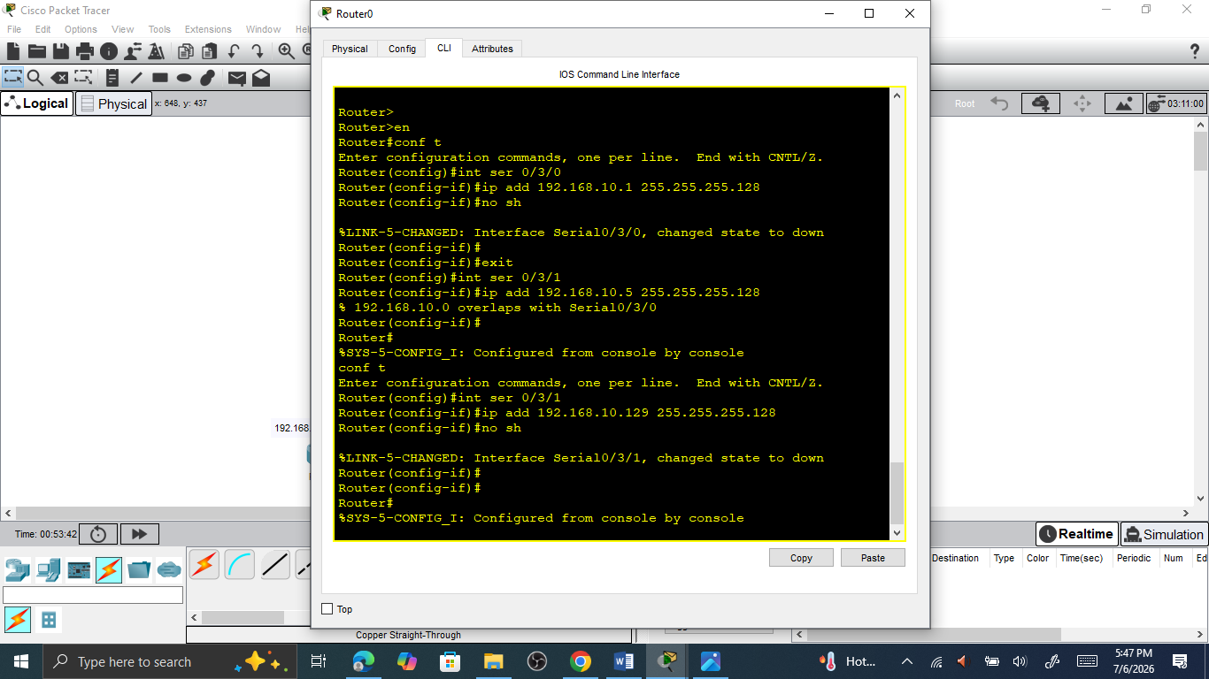
And now here we successfully have assign our ips to the two different interfaces of the router from two different subnets of the same network.
Similarly we will perform further more labs to apply our flsm technique to the allocate ips to different interfaces of the routers
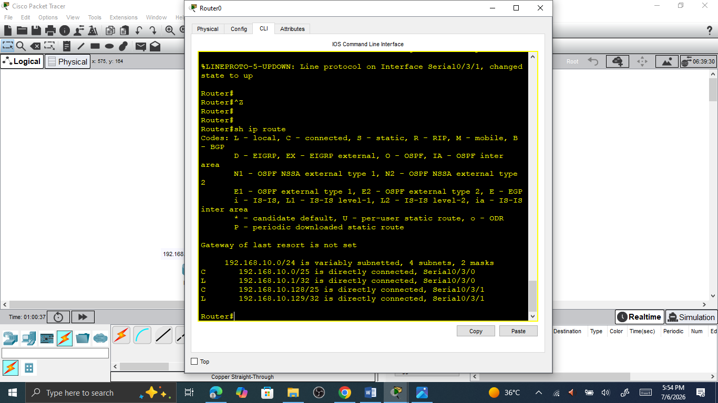
So this is the way we can assign the ips to the different interfaces of the routers different departments or different branches of the company.
Similary no we will be doing some more examples of FLSM
FLSM WORKSHEET
Problem 1
- Major Network Address: 192.168.10.0/24
- Required Subnets: 4
- Custom Subnet Mask (CIDR): /26
- Custom Subnet Mask (Decimal): 255.255.255.192
- Usable Hosts per Subnet: 62

 | Subnet-ids | First useable ip | Last useable ip | Broadcast Address
1 | 192.168.100.0 | 192.168.10.1 | 192.168.10.62 | 192.168.100.63
2 | 192.168.100.64 | 192.168.10.65 | 192.168.10.126 | 192.168.100.127
3 | 192.168.100.128 | 192.168.10.129 | 192.168.10.190 | 192.168.100.191
4 | 192.168.100.192 | 192.168.10.193 | 192.168.10.254 | 192.168.100.255

Problem 2
- Major Network Address: 200.15.4.0/24
- Required Subnets: 8
- Custom Subnet Mask (CIDR): /27
- Custom Subnet Mask (Decimal): 255.255.255.224
- Usable Hosts per Subnet: 30

 | Subnet-ids | First useable ip | Last useable ip | Broadcast Address
1 | 200.15.4.0 | 200.15.4.1 | 200.15.4.30 | 200.15.4.31
2 | 200.15.4.32 | 200.15.4.33 | 200.15.4.62 | 200.15.4.63
3 | 200.15.4.64 | 200.15.4.65 | 200.15.4.94 | 200.15.4.95
4 | 200.15.4.96 | 200.15.4.97 | 200.15.4.126 | 200.15.4.127
5 | 200.15.4.128 | 200.15.4.129 | 200.15.4.158 | 200.15.4.159
6 | 200.15.4.160 | 200.15.4.161 | 200.15.4.190 | 200.15.4.191
7 | 200.15.4.192 | 200.15.4.193 | 200.15.4.222 | 200.15.4.223
8 | 200.15.4.224 | 200.15.4.225 | 200.15.4.254 | 200.15.4.255

Problem 3
- Major Network Address: 210.88.90.0 /24
- Subnet Mask: 28
- Custom CDR 255.255.255.240
- Block Size: 16
- Usable Hosts per Subnet: 14
 | Subnet address | First useable ip | Last useable ip | Broadcast address
1 | 210.88.90.0 | 210.88.90.1 | 210.88.90.14 | 210.88.90.15
2 | 210.88.90.16 | 210.88.90.17 | 210.88.90.30 | 210.88.90.31
3 | 210.88.90.32 | 210.88.90.33 | 210.88.90.46 | 210.88.90.48
4 | 210.88.90.48 | 210.88.90.49 | 210.88.90.62 | 210.88.90.63
5 | 210.88.90.64 | 210.88.90.65 | 210.88.90.78 | 210.88.90.79
6 | 210.88.90.80 | 210.88.90.81 | 210.88.90.94 | 210.88.90.95
7 | 210.88.90.96 | 210.88.90.97 | 210.88.90.110 | 210.88.90.111
8 | 210.88.90.112 | 210.88.90.113 | 210.88.90.126 | 210.88.90.127
9 | 210.88.90.128 | 210.88.90.129 | 210.88.90.142 | 210.88.90.143
10 | 210.88.90.144 | 210.88.90.145 | 210.88.90.158 | 210.88.90.159
11 | 210.88.90.160 | 210.88.90.161 | 210.88.90.174 | 210.88.90.175
12 | 210.88.90.176 | 210.88.90.177 | 210.88.90.190 | 210.88.90.191
13 | 210.88.90.192 | 210.88.90.193 | 210.88.90.206 | 210.88.90.207
14 | 210.88.90.208 | 210.88.90.209 | 210.88.90.222 | 210.88.90.223
15 | 210.88.90.224 | 210.88.90.225 | 210.88.90.238 | 210.88.90.239
16 | 210.88.90.240 | 210.88.90.241 | 210.88.90.254 | 210.88.90.255

Problem 4
- Major Network Address: 195.40.50.0 /24
- Subnet Mask: /25 (255.255.255.128
- Block Size: 128
- Usable Hosts per Subnet: 126

 | Subnet address | First useable ip | Last useable ip | Broadcast address
1 | 195.40.50.0 | 195.40.50.1 | 195.40.50.126 | 195.40.50.127
2 | 195.40.50.128 | 195.40.50.129 | 195.40.50.254 | 195.40.50.255
Problem 5
- Major Network Address: 172.16.0.0 /16
- Subnet Mask: /19 255.255.224.0
- Block Size: 32 (Third Octet)
- Usable Hosts per Subnet: 8,190

Subnet # | Subnet Address | First Usable Host | Last Usable Host | Broadcast Address
Subnet 0 | 172.16.0.0 | 172.16.0.1 | 172.16.31.254 | 172.16.31.255
Subnet 1 | 172.16.32.0 | 172.16.32.1 | 172.16.63.254 | 172.16.63.255
Subnet 2 | 172.16.64.0 | 172.16.64.1 | 172.16.95.254 | 172.16.95.255
Subnet 3 | 172.16.96.0 | 172.16.96.1 | 172.16.127.254 | 172.16.127.255
Subnet 4 | 172.16.128.0 | 172.16.128.1 | 172.16.159.254 | 172.16.159.255
Subnet 5 | 172.16.160.0 | 172.16.160.1 | 172.16.191.254 | 172.16.191.255
Subnet 6 | 172.16.192.0 | 172.16.192.1 | 172.16.223.254 | 172.16.223.255
Subnet 7 | 172.16.224.0 | 172.16.224.1 | 172.16.255.254 | 172.16.255.255

Problem 6 (All 64 Subnets)
- Major Network Address: 150.50.0.0 /16
- Subnet Mask: /22 255.255.252.0
- Block Size: 4 (Third Octet)
- Usable Hosts per Subnet: 1,022

Subnet # | Subnet Address | First Usable Host | Last Usable Host | Broadcast Address
Subnet 0 | 150.50.0.0 | 150.50.0.1 | 150.50.3.254 | 150.50.3.255
Subnet 1 | 150.50.4.0 | 150.50.4.1 | 150.50.7.254 | 150.50.7.255
Subnet 2 | 150.50.8.0 | 150.50.8.1 | 150.50.11.254 | 150.50.11.255
Subnet 3 | 150.50.12.0 | 150.50.12.1 | 150.50.15.254 | 150.50.15.255
Subnet 4 | 150.50.16.0 | 150.50.16.1 | 150.50.19.254 | 150.50.19.255
Subnets 5-59 | ...Increments by 4 | ... | ... | ...
Subnet 60 | 150.50.240.0 | 150.50.240.1 | 150.50.243.254 | 150.50.243.255
Subnet 61 | 150.50.244.0 | 150.50.244.1 | 150.50.247.254 | 150.50.247.255
Subnet 62 | 150.50.248.0 | 150.50.248.1 | 150.50.251.254 | 150.50.251.255
Subnet 63 | 150.50.252.0 | 150.50.252.1 | 150.50.255.254 | 150.50.255.255

Problem 7 (All 512 Subnets)
- Major Network Address: 165.20.0.0 /16
- Subnet Mask: /25 255.255.255.128
- Block Size: 128 (Fourth Octet, alternates third octet)
- Usable Hosts per Subnet: 126

 | Subnet Address | First Usable Host | Last Usable Host | Broadcast Address
Subnet 0 | 165.20.0.0 | 165.20.0.1 | 165.20.0.126 | 165.20.0.127
Subnet 1 | 165.20.0.128 | 165.20.0.129 | 165.20.0.254 | 165.20.0.255
Subnet 2 | 165.20.1.0 | 165.20.1.1 | 165.20.1.126 | 165.20.1.127
Subnet 3 | 165.20.1.128 | 165.20.1.129 | 165.20.1.254 | 165.20.1.255
Subnets 4-509 | ...Increments fourth octet | ... | ... | ...
Subnet 510 | 165.20.255.0 | 165.20.255.1 | 165.20.255.126 | 165.20.255.127
Subnet 511 | 165.20.255.128 | 165.20.255.129 | 165.20.255.254 | 165.20.255.255

Problem 8 (All 4 Subnets)
- Major Network Address: 10.0.0.0 /8
- Subnet Mask: /10 255.192.0.0
- Block Size: 64 (Second Octet)
- Usable Hosts per Subnet: 4,194,302

Subnet # | Subnet Address | First Usable Host | Last Usable Host | Broadcast Address
Subnet 0 | 10.0.0.0 | 10.0.0.1 | 10.63.255.254 | 10.63.255.255
Subnet 1 | 10.64.0.0 | 10.64.0.1 | 10.127.255.254 | 10.127.255.255
Subnet 2 | 10.128.0.0 | 10.128.0.1 | 10.191.255.254 | 10.191.255.255
Subnet 3 | 10.192.0.0 | 10.192.0.1 | 10.255.255.254 | 10.255.255.255

Problem 9 (All 32 Subnets)
- Major Network Address: 24.0.0.0 /8
- Subnet Mask: /13 255.248.0.0
- Block Size: 8 (Second Octet)
- Usable Hosts per Subnet: 524,286

Subnet # | Subnet Address | First Usable Host | Last Usable Host | Broadcast Address
Subnet 0 | 24.0.0.0 | 24.0.0.1 | 24.7.255.254 | 24.7.255.255
Subnet 1 | 24.8.0.0 | 24.8.0.1 | 24.15.255.254 | 24.15.255.255
Subnet 2 | 24.16.0.0 | 24.16.0.1 | 24.23.255.254 | 24.23.255.255
Subnet 3 | 24.24.0.0 | 24.24.0.1 | 24.31.255.254 | 24.31.255.255
Subnets 4-29 | ...Increments by 8 | ... | ... | ...
Subnet 30 | 24.240.0.0 | 24.240.0.1 | 24.247.255.254 | 24.247.255.255
Subnet 31 | 24.248.0.0 | 24.248.0.1 | 24.255.255.254 | 24.255.255.255

Problem 10 (All 1,024 Subnets)
- Major Network Address: 5.0.0.0 /8
- Subnet Mask: /18 255.255.192.0
- Block Size: 64 (Third Octet, loops through second octet)
- Usable Hosts per Subnet: 16,382

Subnet # | Subnet Address | First Usable Host | Last Usable Host | Broadcast Address
Subnet 0 | 5.0.0.0 | 5.0.0.1 | 5.0.63.254 | 5.0.63.255
Subnet 1 | 5.0.64.0 | 5.0.64.1 | 5.0.127.254 | 5.0.127.255
Subnet 2 | 5.0.128.0 | 5.0.128.1 | 5.0.191.254 | 5.0.191.255
Subnet 3 | 5.0.192.0 | 5.0.192.1 | 5.0.255.254 | 5.0.255.255
Subnet 4 | 5.1.0.0 | 5.1.0.1 | 5.1.63.254 | 5.1.63.255
Subnets 5-1021 | ...Increments octets | ... | ... | ...
Subnet 1022 | 5.255.128.0 | 5.255.128.1 | 5.255.191.254 | 5.255.191.255
Subnet 1023 | 5.255.192.0 | 5.255.192.1 | 5.255.255.254 | 5.255.255.255

These were the few practical examples related to flsm. Now we will see some practical enterprise level scenarios
VLSM DATASHEET

Scenario 1

Retail Branch Office (Store Location)
- Base Network: 192.168.10.0/24
- Total Usable Hosts Required: 154 hosts

Subnet Name | Needed Hosts | Allocated Hosts | CIDR | Subnet Mask | Network Address | Usable IP Range | Broadcast Address
Point-of-Sale (POS) Systems | 80 | 126 | /25 | 255.255.255.128 | 192.168.10.0 | 192.168.10.1 - 192.168.10.126 | 192.168.10.127
Guest Wi-Fi | 45 | 62 | /26 | 255.255.255.192 | 192.168.10.128 | 192.168.10.129 - 192.168.10.190 | 192.168.10.191
Store Management PCs | 20 | 30 | /27 | 255.255.255.224 | 192.168.10.192 | 192.168.10.193 - 192.168.10.222 | 192.168.10.223
IP Security Cameras | 7 | 14 | /28 | 255.255.255.240 | 192.168.10.224 | 192.168.10.225 - 192.168.10.238 | 192.168.10.239
Primary WAN to HQ | 2 | 2 | /30 | 255.255.255.252 | 192.168.10.240 | 192.168.10.241 - 192.168.10.242 | 192.168.10.243

2) Remote Engineering & R&D Hub
- Base Network: 192.168.55.0/24
- Total Usable Hosts Required: 101 hosts

Subnet Name | Needed Hosts | Allocated Hosts | CIDR | Subnet Mask | Network Address | Usable IP Range | Broadcast Address
Testing Workstations | 55 | 62 | /26 | 255.255.255.192 | 192.168.55.0 | 192.168.55.1 - 192.168.55.62 | 192.168.55.63
Prototype IoT Lab | 28 | 30 | /27 | 255.255.255.224 | 192.168.55.64 | 192.168.55.65 - 192.168.55.94 | 192.168.55.95
Hub Staff VoIP Phones | 12 | 14 | /28 | 255.255.255.240 | 192.168.55.96 | 192.168.55.97 - 192.168.55.110 | 192.168.55.111
Local Print & NAS Storage | 4 | 6 | /29 | 255.255.255.248 | 192.168.55.128 | 192.168.55.129 - 192.168.55.134 | 192.168.55.135
VPN Gateway Link | 2 | 2 | /30 | 255.255.255.252 | 192.168.55.136 | 192.168.55.137 - 192.168. | 192.168.55.139

Scenario 3: Bank Branch (High Security)
- Base Network: 192.168.200.0/24
- Total Usable Hosts Required: 76 hosts

Subnet Name | Needed Hosts | Allocated Hosts | CIDR | Subnet Mask | Network Address | Usable IP Range | Broadcast Address
Tellers & Customer Service | 40 | 62 | /26 | 255.255.255.192 | 192.168.200.0 | 192.168.200.1 - 192.168.200.62 | 192.168.200.63
ATM Network (Segmented) | 14 | 14 | /28 | 255.255.255.240 | 192.168.200.64 | 192.168.200.65 - 192.168.200.78 | 192.168.200.79
Vault & Alarm Systems | 6 | 6 | /29 | 255.255.255.248 | 192.168.200.80 | 192.168.200.81 - 192.168.200.86 | 192.168.200.87
Branch Manager Office | 4 | 6 | /29 | 255.255.255.248 | 192.168.200.88 | 192.168.200.89 - 192.168.200.94 | 192.168.200.95
SD-WAN Router Interlink | 2 | 2 | /30 | 255.255.255.252 | 192.168.200.96 | 192.168.200.97 - 192.168.200.98 | 192.168.200.99

Scenario 4: Localized Data Center DMZ Zone
- Base Network: 203.0.113.0/24 (Public Class C range)
- Total Usable Hosts Required: 53 hosts

Subnet Name | Needed Hosts | Allocated Hosts | CIDR | Subnet Mask | Network Address | Usable IP Range | Broadcast Address
Web Server Farm | 30 | 30 | /27 | 255.255.255.224 | 203.0.113.0 | 203.0.113.1 - 203.0.113.30 | 203.0.113.31
External Reverse Proxies | 10 | 14 | /28 | 255.255.255.240 | 203.0.113.32 | 203.0.113.33 - 203.0.113.46 | 203.0.113.47
Public DNS Servers | 5 | 6 | /29 | 255.255.255.248 | 203.0.113.48 | 203.0.113.49 - 203.0.113.54 | 203.0.113.55
Firewall HA Heartbeat | 2 | 2 | /30 | 255.255.255.252 | 203.0.113.56 | 203.0.113.57 - 203.0.113.58 | 203.0.113.59
Load Balancer Virtual IPs | 2 | 2 | /30 | 255.255.255.252 | 203.0.113.60 | 203.0.113.61 - 203.0.113.62 | 203.0.113.63

Scenario 5:
Logistics Warehouse & Distribution Site
- Base Network: 192.168.150.0/24
- Total Usable Hosts Required: 192 hosts

Subnet Name | Needed Hosts | Allocated Hosts | CIDR | Subnet Mask | Network Address | Usable IP Range | Broadcast Address
Handheld Wi-Fi Scanners | 115 | 126 | /25 | 255.255.255.128 | 192.168.150.0 | 192.168.150.1 - 192.168.150.126 | 192.168.150.127
Shipping Admin Offices | 50 | 62 | /26 | 255.255.255.192 | 192.168.150.128 | 192.168.150.129 - 192.168.150.190 | 192.168.150.191
Inventory Label Printers | 12 | 14 | /28 | 255.255.255.240 | 192.168.150.192 | 192.168.150.193 - 192.168.150.206 | 192.168.150.207
Climate Control/HVAC IoT | 5 | 6 | /29 | 255.255.255.248 | 192.168.150.208 | 192.168.150.209 - 192.168.150.214 | 192.168.150.215
Main Site Gateway Link | 2 | 2 | /30 | 255.255.255.252 | 192.168.150.216 | 192.168.150.217 - 192.16

VLAN CONFIGURATION PROJECT
Now we will work upon the vlan configuration project.
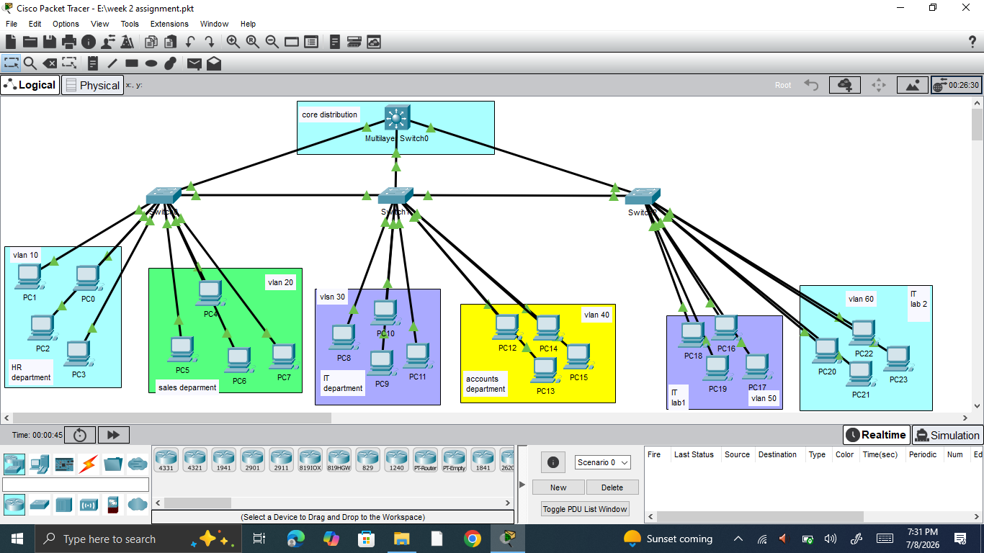
This is the topology where we will configure the vlans and will perform inter vlan routing also so all the pcs and interconnected departments/vlans will communicate and share resources with each other
OUR Equipment used in lab:
- Layer 3 switch (perform inter vlan routing)
- 3 layer 2 switches (2 vlans each)
- Pcs 4 to 8 pcs each vlan or department

Pcs configurations

We have subnetted a base network 192.168.10.0/24 to 8 subnets containing 32 ips each subnet 30 useable ips each subnet
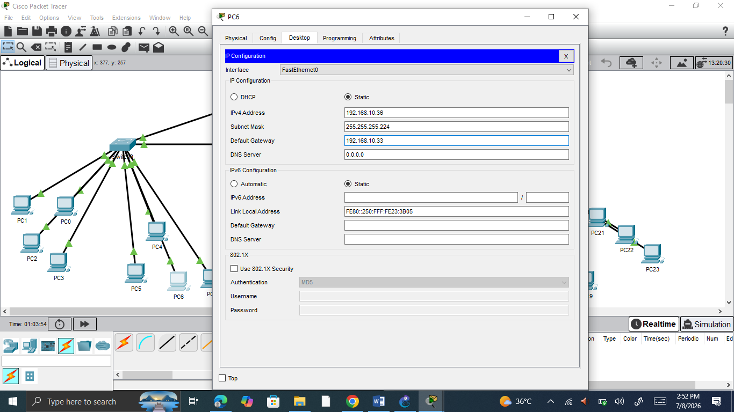
Each pc in every vlan and department is assigned with the ip from the respective subnet and the gateway.
Switch configurations
Our switches are configured as follow
The switch enterfacees of all 3 switches are divided into 2 vlans interfaces
switch 1
interface 0/1 to 0/10 vlan 10 name HR
Interface 0/11 to 0/19 vlan 20 name sales
Interface 0/20 trunk link to layer 3 router
Switch 2 & switch 3 similarly as switch 1
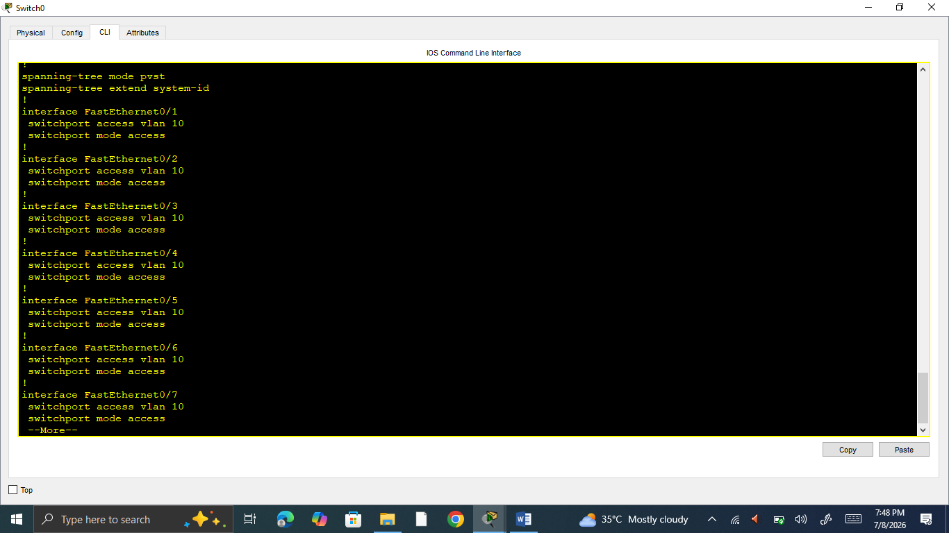
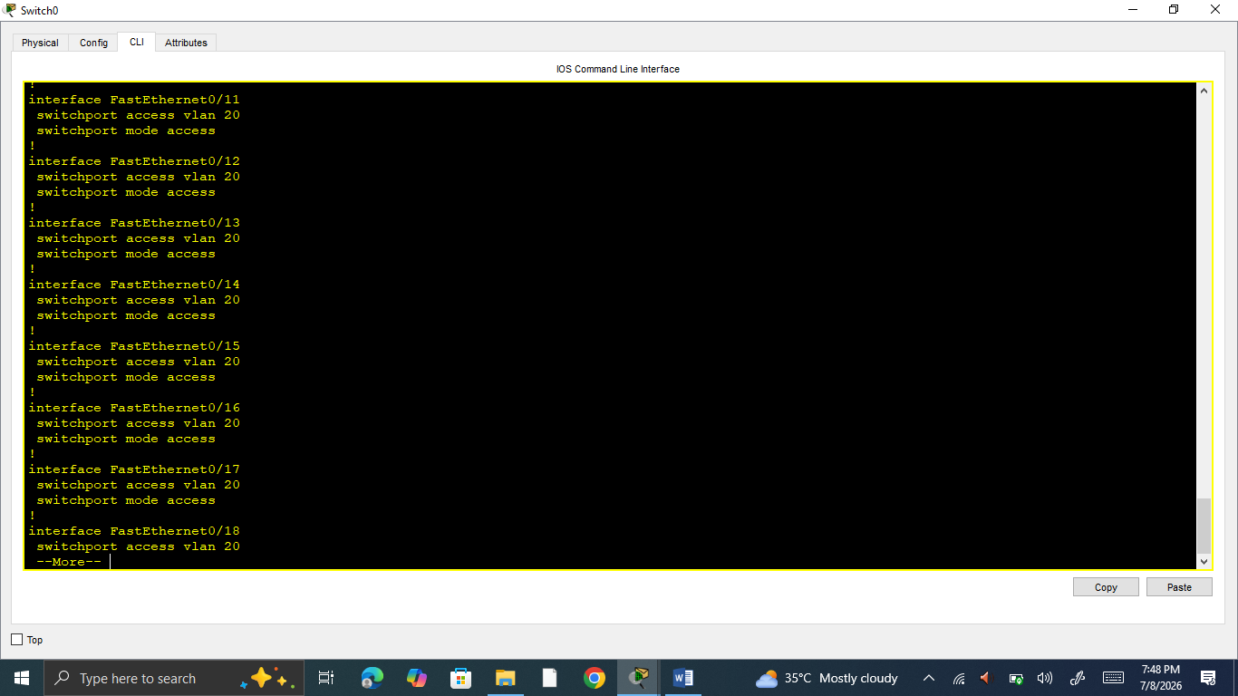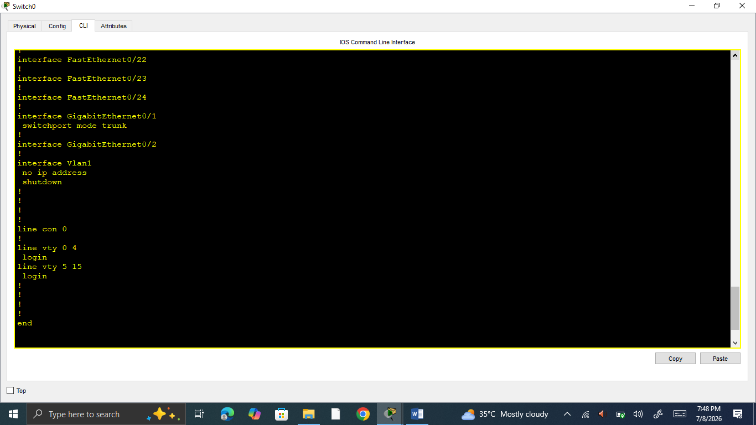

LAYER 3 switch configurations for inter valn routing
We configured layer 3 switch for inter valn routing ,configured the interfaces as the trunck interfaces for intervlan trafic routing
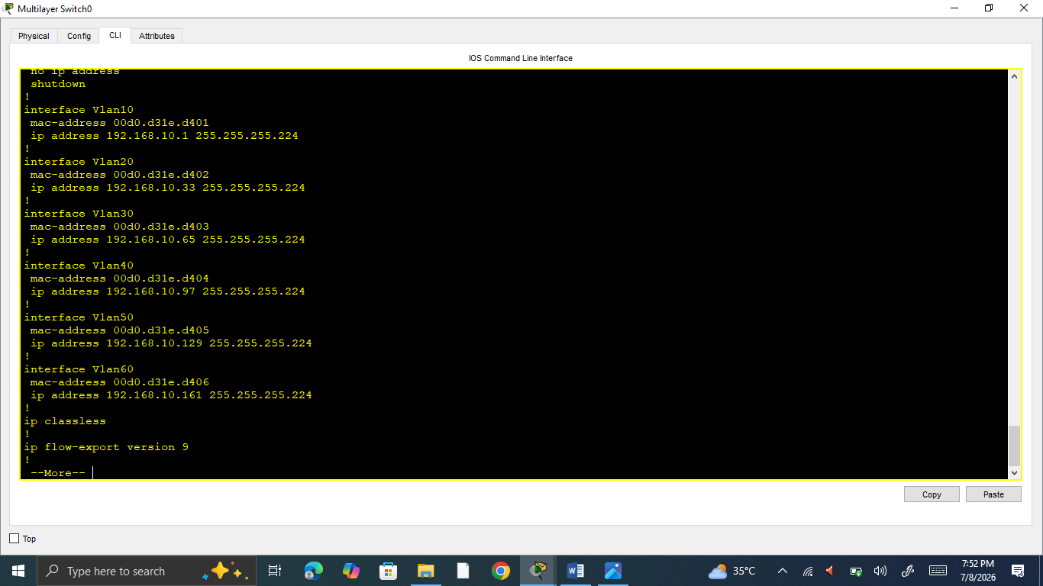

Successful connectivity of all the pcs
As we completed our configurations and has configured the vlans and inter vlan routing assign the ip addresses to the pcs then we ping different pcs along the complete network and successfully ping throughout the network
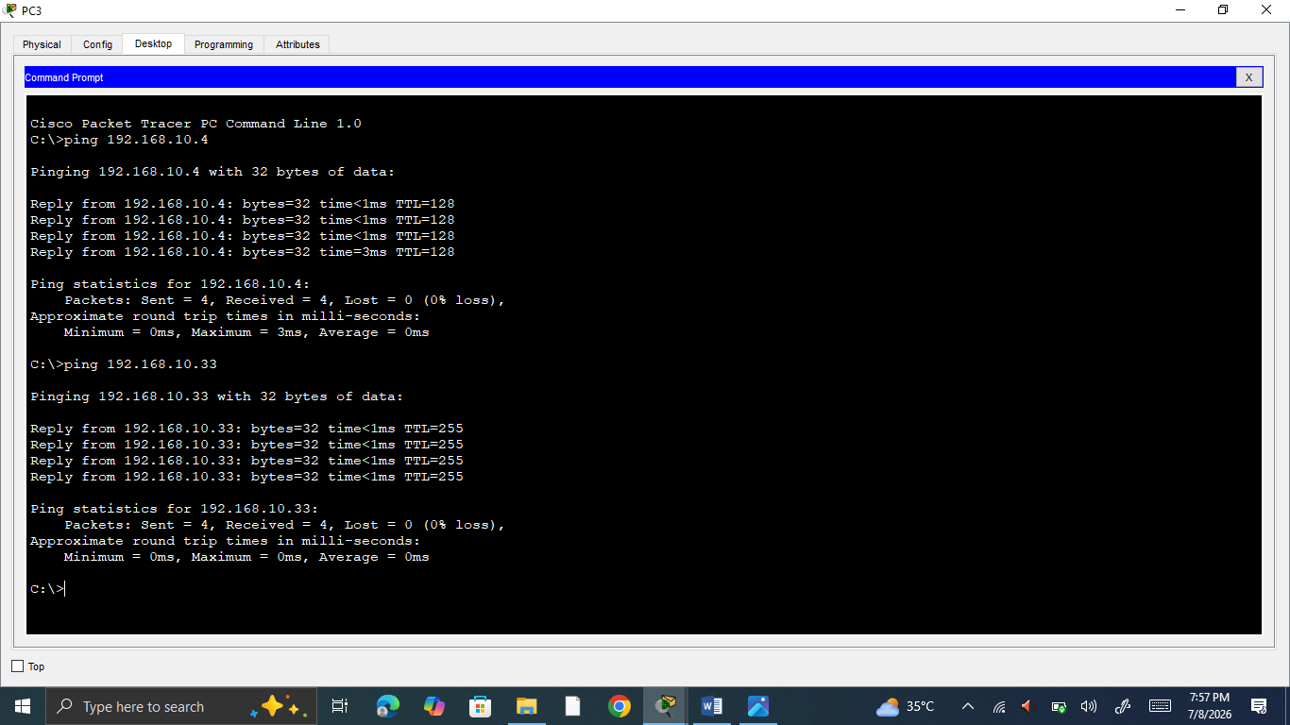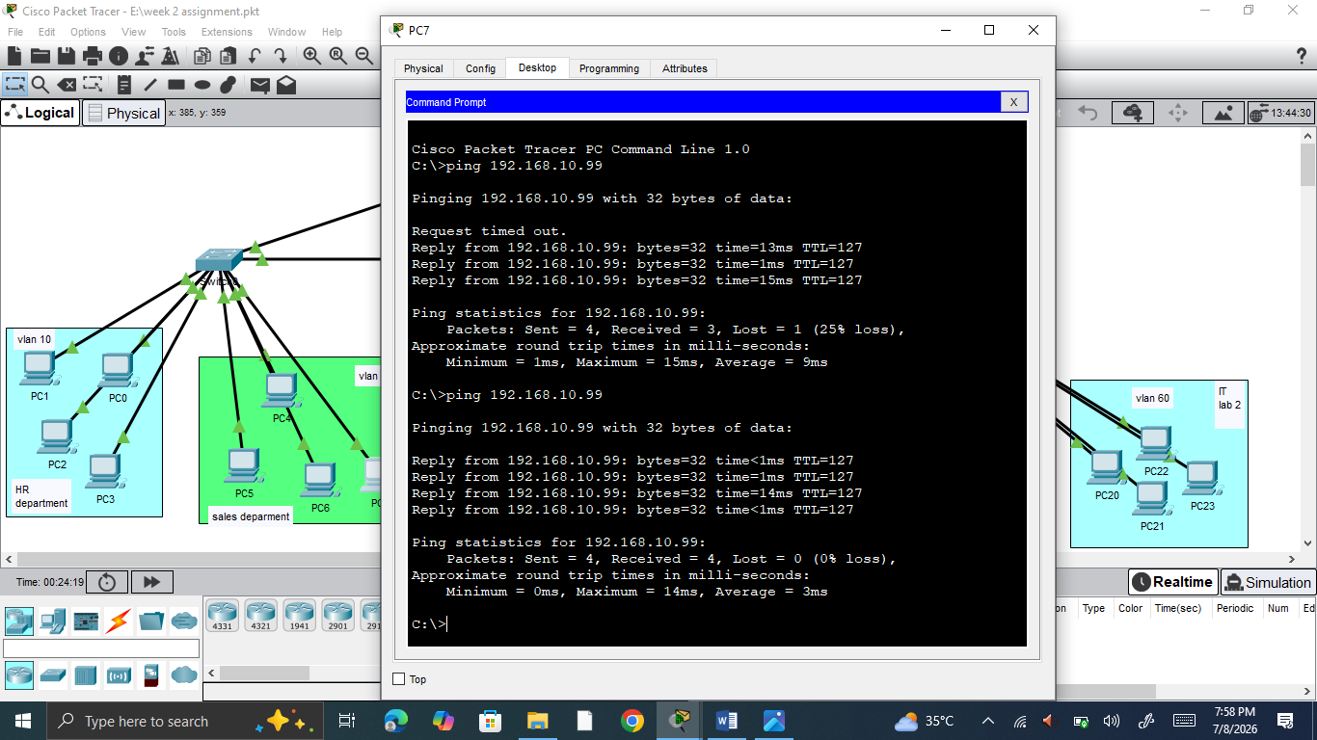

Similary we perform the in gns 3 we also created and worked upon the topology where we connected two switches via trunk links and created different vlans and attached the respective department traffic for smooth connectivity and resource sharing without creating excess broadcast domais in the switches
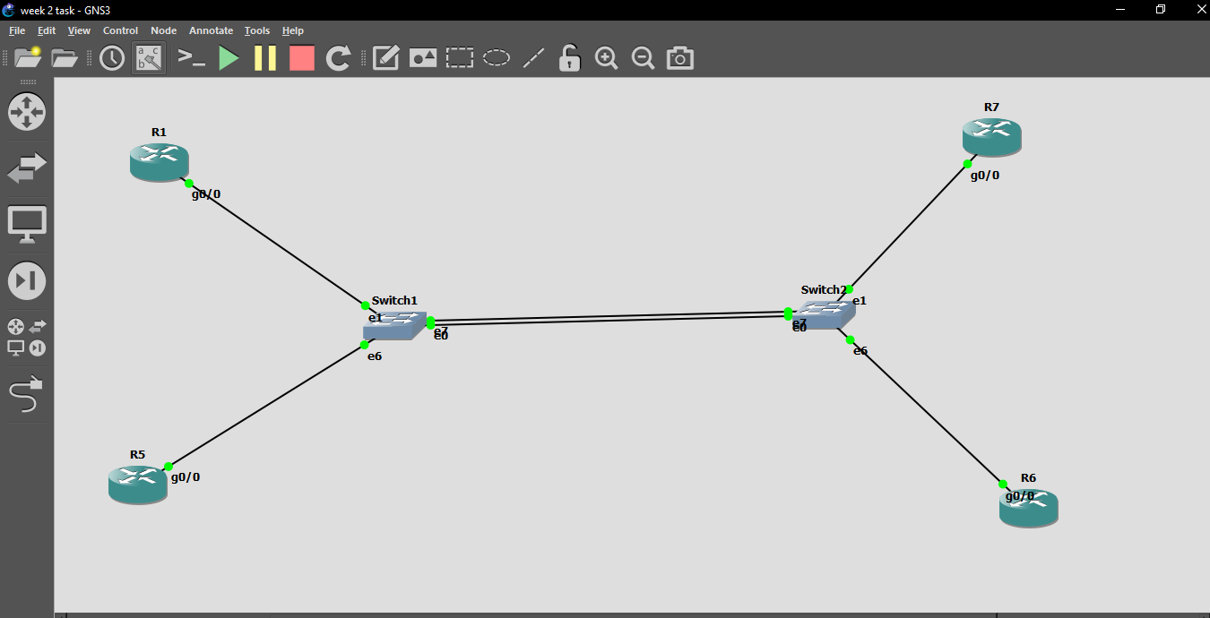
REPORT SUMMARY
- FLSM
- VLSM
- VLANS creation
- Intervlan routing

